ISLAMIC UNIVERSITY OF TECHNOLOGY

Organization of Islamic Cooperation

Board Bazar, Gazipur

Laboratory Report

CSE 4512

**Title**: Understanding the basics of IP subnetting and Variable Length Subnet Mask (VLSM) and to know Secure Shell (SSH) and Telnet basics.

**Objectives**:

* Understand the basics of IP Subnetting.
* Learn to subnet a network following given specifications.
* Understand Variable Length Subnet Mask (VLSM) addressing scheme.
* Learn to design and implement VLSM in a network.
* Get to know Secure Shell (SSH) and Telnet basics.

**Diagram of the experiment**:

TASK #01:

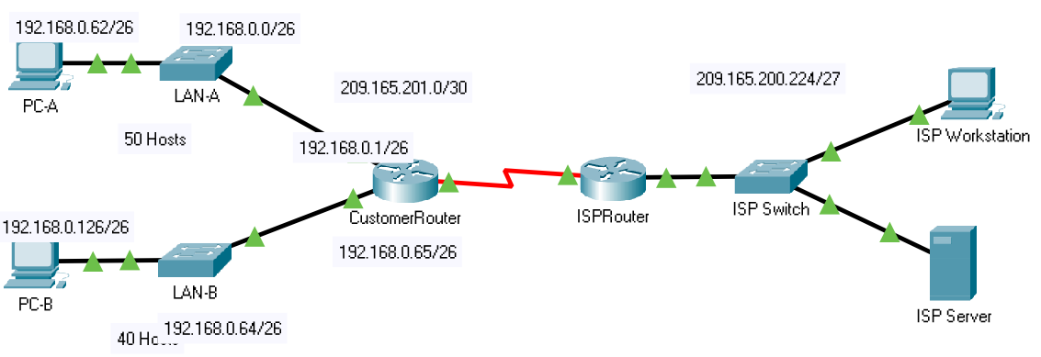

TASK #02:

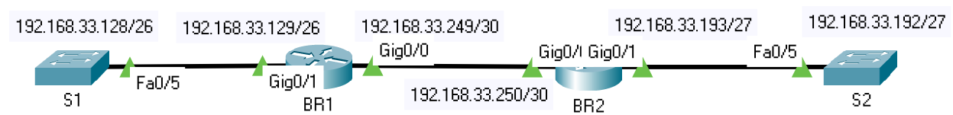

TASK #03:



**Working Procedure**:

TASK #01:

1. The different IP addresses and subnet masks were determined by answering the questions and filling up the Addressing Table.
2. The CustomerRouter was configured.

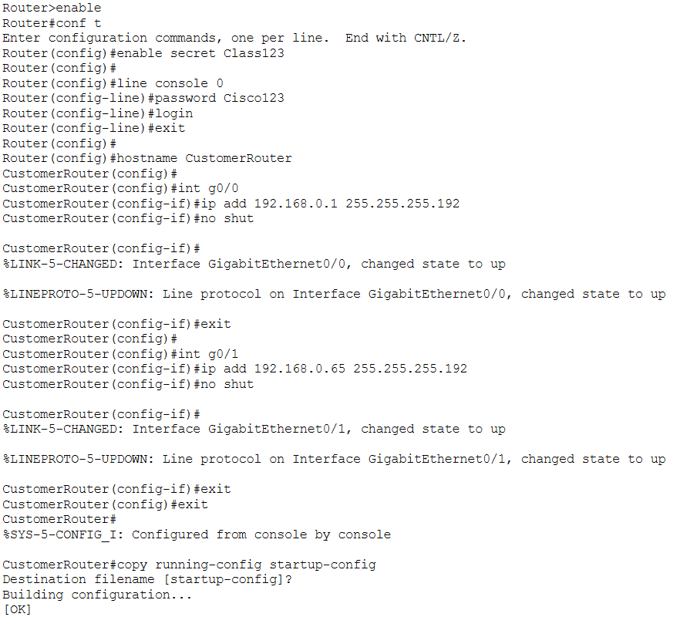



1. The two PCs were configured.

PC-A:

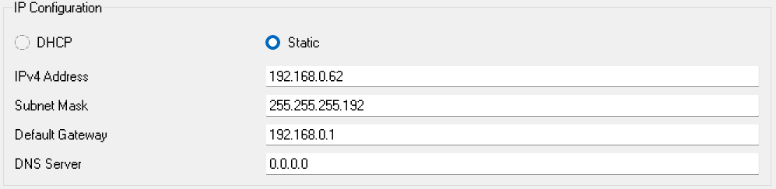

PC-B:

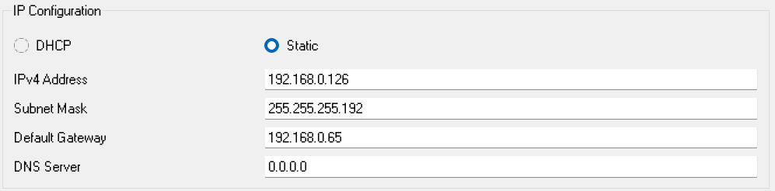

1. The connection of each PC with the default gateway and with each other was checked.

PC-A to Default Gateway:

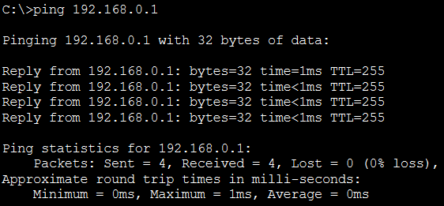

PC-B to Default Gateway:

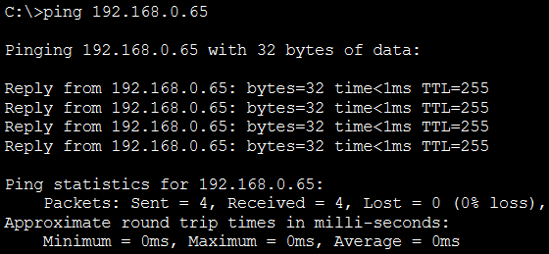

PC-A to PC-B:

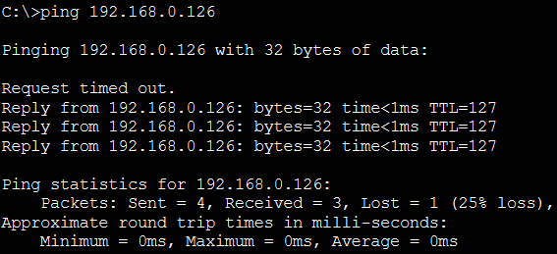

TASK #02:

1. The different IP addresses and subnet masks were determined by answering the questions and filling up the VLSM Address Scheme below.
2. Devices were added to the Logical Workspace following the diagram shown above. The 2911 router was used since 4221 was unavailable.
3. The routers were configured.

BR1:

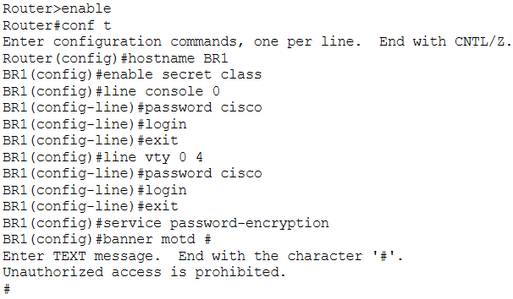

BR2:

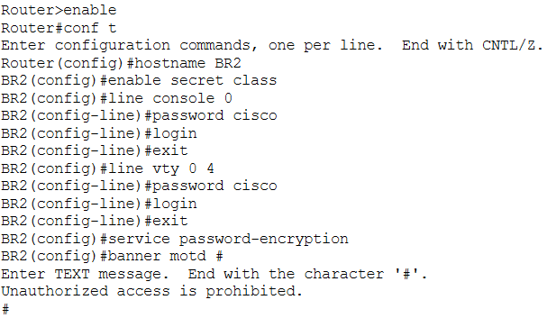

1. The router interfaces were configured.

BR1:

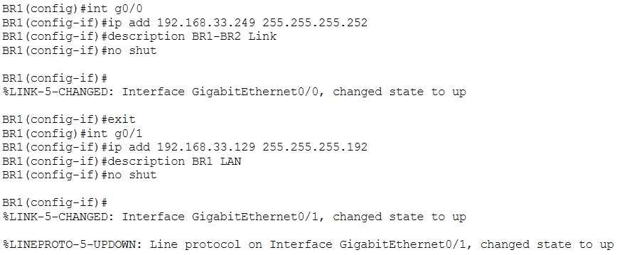

BR2:

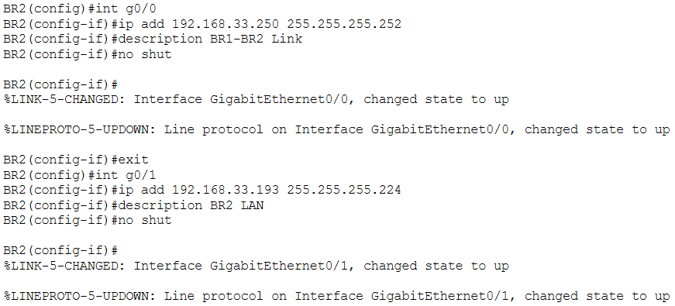



1. The configurations for each router were saved.

BR1:

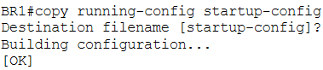

BR2:

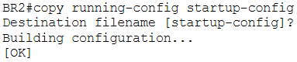

1. The connectivity of each router with the other was tested.

BR1:

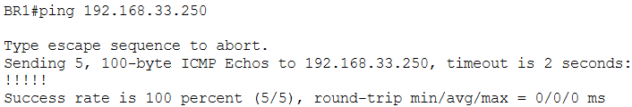

BR2:

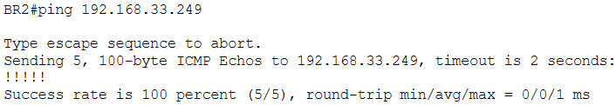

TASK #03:

1. The CustomerRouter SSH was configured.

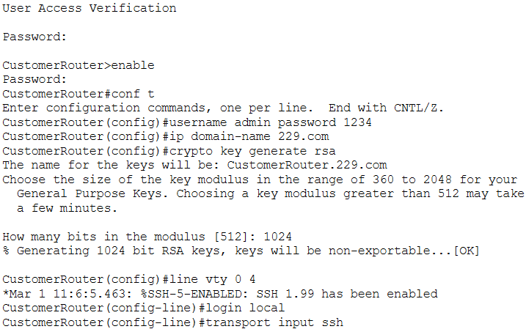

1. It was confirmed that the configuration was successful by connecting to the CustomerRouter from PC-A.

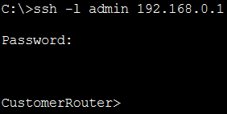

Fill in the missing IP address in the addressing table (Task #01):

Fill in the addressing table with missing IP Address following the steps in Step 2 of Part 1:

|  |  |  |  |  |
| --- | --- | --- | --- | --- |
| Device | Interface | IP Address | Subnet Mask | Default Gateway |
| CustomerRouter | G0/0 | 192.168.0.1 | 255.255.255.192 | N/A |
| G0/1 | 192.168.0.65 | 255.255.255.192 |
| S0/1/0 | 209.165.201.2 | 255.255.255.252 |
| Lan-A Switch | VLAN1 |  |  |  |
| Lan-B Switch | VLAN1 |  |  |  |
| PC-A | NIC | 192.168.0.62 | 255.255.255.192 | 192.168.0.1 |
| PC-B | NIC | 192.168.0.126 | 255.255.255.192 | 192.168.0.65 |
| ISPRouter | G0/0 | 209.165.200.225 | 255.255.255.224 | N/A |
| S0/1/0 | 209.165.201.1 | 255.255.255.252 |
| ISP Switch | VLAN1 | 209.165.200.226 | 255.255.255.224 | 209.165.200.225 |
| ISP Workstation | NIC | 209.165.200.235 | 255.255.255.224 | 209.165.200.225 |
| ISP Server | NIC | 209.165.200.240 | 255.255.255.224 | 209.165.200.225 |

Table: Addressing Table

Design the VLSM Address Scheme (Task 2):

Calculate the information that you obtained in Part 1 to fill in the following table

|  |  |  |  |  |
| --- | --- | --- | --- | --- |
| Subnet Description | Number of Hosts Needed | Network Address /CIDR | First Host Address | Broadcast Address |
| BR1 LAN | 40 | 192.168.33.128/26 | 192.168.33.129 | 192.168.33.191 |
| BR2 LAN | 25 | 192.168.33.192/27 | 192.168.33.193 | 192.168.33.223 |
| BR2 IoT LAN | 5 | 192.168.33.224/29 | 192.168.33.225 | 192.168.33.231 |
| BR2 CCTV LAN | 4 | 192.168.33.232/29 | 192.168.33.233 | 192.168.33.239 |
| BR2 HVAC C2LAN | 4 | 192.168.33.240/29 | 192.168.33.241 | 192.168.33.247 |
| BR1-BR2 Link | 2 | 192.168.33.248/30 | 192.168.33.249 | 192.168.33.251 |

Questions:

TASK #01 - Part 1 – Step 1:

Question: How many host addresses are needed in the largest required subnet?

Answer: 50

Question: What is the minimum number of subnets required?

Answer: 4

Question: The network that you are tasked to subnet is 192.168.0.0/24. What is the /24 subnet mask in binary?

Answer: 11111111.11111111.11111111.00000000

The subnet mask is made up of two portions, the network portion, and the host portion. This is represented in the binary by the ones and the zeros in the subnet mask.

Question: In the network mask, what do the ones represent?

Answer: The network portion.

Question: In the network mask, what do the zeros represent?

Answer: The host portion.

To subnet a network, bits from the host portion of the original network mask are changed into subnet bits. The number of subnet bits defines the number of subnets.

Question: Given each of the possible subnet masks depicted in the following binary format, how many subnets and how many hosts are created in each example?

(/25) 11111111.11111111.11111111.10000000

Dotted decimal subnet mask equivalent: 255.255.255.128

Number of subnets? Number of hosts?: 2 subnets, 126 hosts per subnet.

(/26) 11111111.11111111.11111111.11000000

Dotted decimal subnet mask equivalent: 255.255.255.192

Number of subnets? Number of hosts?: 4 subnets, 62 hosts per subnet.

(/27) 11111111.11111111.11111111.11100000

Dotted decimal subnet mask equivalent: 255.255.255.224

Number of subnets? Number of hosts?: 8 subnets, 30 hosts per subnet.

(/28) 11111111.11111111.11111111.11110000

Dotted decimal subnet mask equivalent: 255.255.255.240

Number of subnets? Number of hosts?: 16 subnets, 14 hosts per subnet.

(/29) 11111111.11111111.11111111.11111000

Dotted decimal subnet mask equivalent: 255.255.255.248

Number of subnets? Number of hosts?: 32 subnets, 6 hosts per subnet.

(/30) 11111111.11111111.11111111.11111100

Dotted decimal subnet mask equivalent: 255.255.255.252

Number of subnets? Number of hosts?: 64 subnets, 2 hosts per subnet.

Question: Considering your answers above, which subnet masks meet the required number of minimum host addresses?

Answer: 255.255.255.128 and 255.255.255.192

Question: Considering your answers above, which subnet masks meets the minimum number of subnets required?

Answer: 255.255.255.192, 255.255.255.224, 255.255.255.240, 255.255.255.248 and 255.255.255.252.

Question: Considering your answers above, which subnet mask meets both the required minimum number of hosts and the minimum number of subnets required?

Answer: 255.255.255.192

When you have determined (Step 1 of Part 1) which subnet mask meets all of the stated network requirements, derive each of the subnets. List the subnets from the fast to last in the table. Remember that the first subnet is 192.168.0.0 with the chosen subnet mask.

|  |  |  |
| --- | --- | --- |
| Subnet Address | Prefix | Subnet Mask |
| 192.168.0.0 | /26 | 255.255.255.192 |
| 192.168.0.64 | /26 | 255.255.255.192 |
| 192.168.0.128 | /26 | 255.255.255.192 |
| 192.168.0.192 | /26 | 255.255.255.192 |

TASK #01 - Part 3:

Question: Determine if PC-A can communicate with its default gateway. Do you get a reply?

Answer: Yes.

Question: Determine if PC-B can communicate with its default gateway. Do you get a reply?

Answer: Yes.

Question: Determine if PC-A can communicate with PC-B. Do you get a reply?

Answer: Yes.

TASK #02 - Part 1 – Step 1:

Question: How many host addresses are available in a /25 network?

Answer: 126

Question: What is the total number of host addresses needed in the topology diagram?

Answer: 80

Question: How many subnets are needed in the network topology?

Answer: 6

TASK #02 - Part 1 – Step 2: Determine the largest subnet.

Question: What is the subnet description (e.g., BR1 LAN or BR1-BR2 link)?

Answer: BR1 LAN

Question: How many IP addresses are required in the largest subnet?

Answer: 40

Question: What subnet mask can support that many host addresses?

Answer: 255.255.255.192

Question: How many total host addresses can that subnet mask support?

Answer: 62

Question: Can you subnet the 192.168.33.128/25 network address to support this subnet?

Answer: Yes.

Question: What are the network addresses that would result from this subnetting?

Answer: 192.168.33.128 and 192.168.33.192

TASK #02 - Part 1 – Step 3: Determine the second largest subnet.

Question: What is the subnet description?

Answer: BR2 LAN

Question: How many IP addresses are required in the second largest subnet?

Answer: 25

Question: What subnet mask can support that many host addresses?

Answer: 255.255.255.224

Question: How many total host addresses can that subnet mask support?

Answer: 30

Question: Can you subnet the remaining subnet again and still support this subnet?

Answer: Yes.

Question: What are the network addresses that would result from this subnetting?

Answer: 192.168.33.192 and 192.168.33.224

TASK #02 - Part 1 – Step 4: Determine the third largest subnet.

Question: What is the subnet description?

Answer: BR2 IoT LAN

Question: How many IP addresses are required in the third largest subnet?

Answer: 5

Question: What subnet mask can support that many host addresses?

Answer: 255.255.255.248

Question: How many total host addresses can that subnet mask support?

Answer: 6

Question: Can you subnet the remaining subnet again and still support this subnet?

Answer: Yes.

Question: What are the network addresses that would result from this subnetting?

Answer: 192.168.33.224, 192.168.33.232, 192.168.33.240, 192.168.33.248

TASK #02 - Part 1 – Step 5: Determine the fourth largest subnet.

Question: What is the subnet description?

Answer: BR1-BR2 Link

Question: How many IP addresses are required in the fourth largest subnet?

Answer: 2

Question: What subnet mask can support that many host addresses?

Answer: 255.255.255.252

Question: How many total host addresses can that subnet mask support?

Answer: 2

Question: Can you subnet the remaining subnet again and still support this subnet?

Answer: Yes.

Question: What are the network addresses that would result from this subnetting?

Answer: 192.168.33.248, 192.168.33.252

TASK #02 – Reflection Question:

Question: Can you think of a shortcut for calculating the network addresses of consecutive /30 subnets?

Answer: A /30 subnet has 2 bits left for the host portion, meaning there are 4 host addresses in the subnet. Thus, if we have one /30 subnet’s network address, the next one can be found by added 4 to the decimal value in the fourth octet.

**Challenges**:

Task 2 presented somewhat of a challenge. The majority of the theory portion of this topic concentrated on subnetting, not VLSM. Thus, it took a while to get comfortable with VLSM, although knowing the basics of subnetting definitely helped.